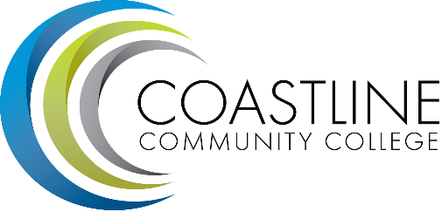
College Council Committee Agenda
July 11, 2017, 9:00 – 11:00 a.m.
President’s Conference Room, College Center

Committee Mandate: To act on College committee and constituency recommendations, to foster College communication and information sharing, and to review overall College operations.

- CALL TO ORDER
  - Roll Call
  - Welcome
  - Adoption of Agenda
  - *Approval of Minutes:
- June 13, 2017

- SPECIAL REPORTS/UPDATES
2.1 Constituency Updates
Academic Senate (Stephen Barnes)
Associated Student Government (Carlos Bahena)
Classified Senate (Kevin Donahue)
Management Team (Lori Adrian)

2.2 College Event Calendar

- PRESIDENT/VPs Brief Reports (Adrian, Groot, Miyashiro, Nguyen, Rodriguez) (1-2 min)

4. ACTION ITEMS
  - Follow-Up on Action Items from May 23, 2017 meeting:
    - Joycelyn Groot will provide a recommendation for a division name change to replace MECTBD/BDATS and a suggested committee planning structure at the next meeting.
Joycelyn provided copies of an outline and synopsis for a new proposed named change from MECTBD/BDATS to Extended Learning Division and creation of a new Division planning group and sub-working groups within the Division. Joycelyn also described how an integrated planning and marketing process would function in the future. The committee reviewed the composition of members for the new working division and provided feedback about the proposed name change. A decision was made to postpone approval until faculty members have an opportunity to provide input for these changes to be implemented. DEFERRED

  - Follow-Up on Action Items from June 13, 2017 meeting:
4.2.1 Aeron Zentner will complete an analysis of the Financial Aid Federal Program Review survey results related to biannual review of Drug and Alcohol Policy, and provide a report back to the committee
4.2.2 Aeron Zentner will compile a report of Graduation and Degree Statistics and provide a report at the next meeting.

5. STANDING REPORTS
  - Budget Update (Christine Nguyen)
  - PIEAC (Stephen Barnes/Vince Rodriguez)
  - *Program/Department Review (Stephen Barnes/Aeron Zentner)
  - Student Success Committee (Ross Miyashiro)
  - Facilities, Safety & Sustainability (FSS) Committee (Christine Nguyen)
  - Technology Committee (Christine Nguyen)
  - Accreditation (Vince Rodriguez)
  - Financial Aid Federal Program Review
6. DISCUSSION ITEMS
6.1 Special Report on Annual Financial Aid Audit Findings (Steve/Ross)
6.2 Update on All College meeting (Ann/Vince)
6.3 College Council Goals for 2017-18
6.4 Committee List 2017-18 (Martha)

7. ANNOUNCEMENTS

- SUMMARY OF KEY ITEMS DISCUSSED/ACTIONS TAKEN

- ADJOURNMENT
9.1 Items for next meeting:
*Attachment has been emailed.
**Attachment available at meeting.

